EXETER MALE VOICE CHOIR
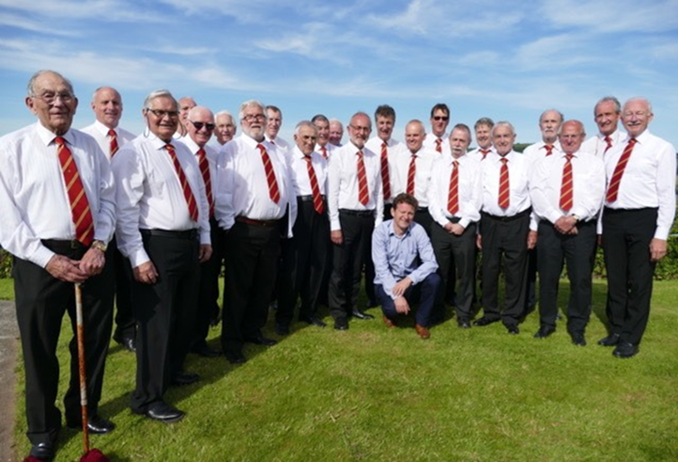
The Choir SPRING into action for their
First Concert of the Season.

CONCERT AT WONFORD METHODIST CHURCH
Burnthouse Lane, Exeter, EX2 6NG
Saturday 27th April 7.30pm
A variety of Modern songs and Popular favourites
To raise Funds for two Charities:
Action for Children and YMCA Exeter
No ticket needed. Please make a donation.

